Venue Hire Application Pack 2020
Box Hill Community Arts Centre
470 Station Street
Box Hill VIC 3128
Phone: 9895 8888 Fax: 9899 4380
Email: bhcac@whitehorse.vic.gov.au
Web: www.bhcac.com.au

Contents

DEFINITIONS……………………………………………………………………………………………………….......4
BHCAC CONDITIONS OF HIRE
1.0 BOOKINGS
1.1 Application for Hire 5
1.2 Deposits and Payments/Security Requirments 5
1.3 Cancellation of Bookings 6
1.4 Equipment Hire 6
1.5 Security 6
2.0 LIABILITY OF HIRER
2.1 Observance of Laws 7
2.2 Insurance 7
2.3 Damage to Persons/Building/Equipment 7
2.4 Minors/Supervision of Groups 8
3.0 ADHERENCE TO LAWS
3.1 Consumption of Liquor 8
3.2 No Smoking 8
3.3 Gambling 9
3.4 Advertisements/Publicity 9
3.5 Noise Levels 9
3.6 Fire and Health Regulations 10
3.7 Occupational Health & Safety 10-11
3.8 Animals 11
3.9 Parking 11
4.0 GENERAL CONDITIONS FOR ALL HIRERS
4.1 Access 11-12
4.2 Behaviour 12
4.3 Cleaning 13
4.4 Use of Piano 13
4.5 Protection of Floors 13
4.6 Furniture 14
4.7 Equipment Storage 14

5.0 EMERGENCY INFORMATION
5.1 Emergency Procedures 15-16
5.2 Incident Notification Flow Chart 17
5.3 Serious Incident Notification Flow Chart 18-19
5.4 Emergency Evacuation Map 20
6.0 VENUE HIRE RATES & APPLICATION FOR HIRE
6.1 Venue Hire Rates - Casual Hirer Rates 21
6.2 Venue Hire Rates - Function Rates & Equipment Hire Rates 22
6.3 Venue Hire Rates - Regular Hirer Rates 23
6.4 Application for Hire 24-25

In the event of any dispute or differences arising as to the interpretation of these conditions or of any
matter or thing contained therein, the decision of Management shall thereon be final and conclusive.
Definitions

Council – Whitehorse City Council
BHCAC – Box Hill Community Arts Centre
Centre Management – Centre Coordinator of BHCAC and/ or their representative including Staff of BHCAC and Council
Hirer – the Hirer specified in the Application for Hire, including the Hirer’s members, employees, agents, invitees and persons the Hirer allows into their sessions at the Centre.
Sessions – Room and times booked as per signed Application for Hire
Regular User – Any group, individual or organisation that hires sessions at BHCAC on an on- going basis. At least six (6) bookings per year must be booked, confirmed and paid for. Regular User must have Public Liability Insurance to the value of $20,000,000.
Casual User - Any group, individual or organisation that hires sessions at BHCAC on an on irregular basis. Casual Users can purchase Hirers Public Liability Insurance from Council.

Discount Support for Venue Hire – Is part of the City of Whitehorse Community Grants Program and supports the community by facilitating the provision of services that meet community needs, provide value for money, promote community spirit and celebrate Whitehorse’s heritage and diversity. The Community Grant Program has FOUR OBJECTIVES which are listed below.
• To support community organisations to provide projects or activities which meet the social, cultural, economic, recreational and development needs of residents.
• To foster a sense of community identity across the City of Whitehorse and improved community linkages.
• To maximise access to programs and activities by people who have limited participation in these activities to date, and
• To encourage co-operation between organisations leading to enhanced program or activity delivery and more efficient use of resources.
If you believe that your booking at BHCAC falls into the above category please ask for a City of Whitehorse Discount Support - Hall Hire Application Form at time of booking.

BHCAC Conditions of Hire

Bookings

Application for Hire
- An Application for Hire must be completed, signed and forwarded to BHCAC prior to the date of the booking.

- After reading and signing the Application for Hire form, the Hirer agrees to comply with the BHCAC Conditions of Hire.

- Please note that you will be agreeing to the BHCAC Conditions of Hire for all members of your group, and it is your responsibility to make all members aware of the said Conditions.

- Hirers must adhere to numbers stipulated on the booking forms. Centre Management must be informed if a difference in numbers is anticipated.

- Advance bookings are required to ensure that BHCAC is available.

- All new hirers must undertake an OH&S induction with Centre Management prior to the commencement of their booking/s. All regular hirers must attend an Emergency Evacuation training session.

- Alterations to bookings must be reported to Centre Management immediately.
- Hirers wishing to apply for City of Whitehorse Discount Support - Hall Hire must provide a completed application form and supporting documentation at the time of booking.

- BHCAC reserves the right to vary the fees and charges as set out in BHCAC Venue Hire Rates at any time without notice.

- BHCAC shall not be held liable for any interference or disruption to a booking that is caused by some civil disturbance, industrial action, act of God, or any circumstances that are beyond the control of Centre Management.

Deposits and Payments/Security Requirement
- Full payment is required upon confirmation of a function booking. Functions include weddings, birthdays, anniversaries and celebrations.

- New customers who intend to regularly use the BHCAC will be required to pay a deposit which represents the total of the first four bookings.

- A $100 deposit is required on confirmation of all gallery/exhibition bookings.

- All other payments are required upon receipt of an invoice and to be paid within 30 days.

Cancellation of Bookings
- Regular and Casual Hirers - Full payment will be charged if cancellations for bookings are received less than 28 days prior to booking(s). 10% of the booking fee will be retained for those cancellations received before 28 days of the booking date.

- Gallery/Exhibition Hirers - $100 deposit will be retained if exhibitions are cancelled less than three months prior to set up date. Full payment will be charged if cancellations for exhibitions are received less than 28 days prior to set up date.

Equipment Hire

Availability must be confirmed with the Centre Management at least two weeks prior to the booking.

All electrical items brought into BHCAC must be tested and tagged by a licensed electrician.

Equipment available for hire:

Portable PA – Includes Microphone, CD Player and Auxiliary Input

TV & DVD Player

Data Projector & Screen/Laptop

Whiteboard (BYO whiteboard markers)

Barbeque

Professional Audio & Lighting equipment in the Arbour

(A qualified City of Whitehorse Audio & Lighting technician must be hired in conjunction with professional audio & lighting hire, please contact Centre Management for more details)

Security
- Centre Management, at their discretion, may direct the Hirer to ensure the attendance of Police, Fire Brigade, Security Staff or registered and licensed Crowd Controllers and a City of Whitehorse Officer at their function. The Hirer shall be responsible for any costs involved in such attendance.

- In the case of Security Staff and registered and licensed Crowd Controllers, the number of personnel required will be decided by Centre Management having regard to the nature of the function.

- If Security Staff or Crowd Controllers are required, they must be in attendance at BHCAC from commencement to the end of the function.

- If a Hirer fails to adhere to these Conditions, Centre Management has the right to cancel the function.

Liability of Hirer

Observance of Laws
- The Hirer shall comply with all Acts and Statutory Rules, Provisions and Regulations and Local Laws of the Commonwealth of Australia, State of Victoria and Whitehorse City Council and shall be liable for any breach of such. Including but not limited to: Occupational Health and Safety Regulations, Food Handling Guidelines, Liquor Licensing Laws, Copyright Legislation and Local Area Work Agreement (LAWA).

Insurance
- Regular Hirers must have Public Liability Insurance to the minimum value of $20,000,000 current at the time of the hire of the venue, and be able to supply BHCAC with a copy of the Certificate of Currency on confirmation of the booking.

- Casual Hirers who do not have their own Public Liability Insurance must pay per booking to be covered under Council’s Hirers Public Liability policy.

- Hirers without a current Certificate of Public Liability insurance at the time of the function will not be allowed to proceed with hiring of booked spaces.
- Hirers are responsible for workers’ compensation or similar insurance over their servants or voluntary workers and for all insurance coverage on goods and services they cause to be brought into the complex. No responsibility will be borne by BHCAC for any goods and services owned by the Hirer.

Damages to Persons/Building/Equipment
- The fittings and fixtures of BHCAC must not be broken, pierced by nails or screws or in any other way damaged.

- The Hirer must replace any Council property, which is deemed by Centre Management to be damaged beyond reasonable repair.

- The Hirer will be liable for any costs incurred by Council in repairing, making good any damage and any non-routine cleaning of BHCAC, its fixtures, fittings and any equipment contained therein.

- In the event that the BHCAC building, or any curtains, floors, fittings, furniture or equipment, is damaged to such an extent that it affects another Hirer’s use of BHCAC or requires a booking to be cancelled, the Hirer will be liable for all costs and losses incurred by Council (including the costs of repairing such damage), refunds of deposits, hiring fees and other loss of revenue.

- No notice, sign, advertisement, scenery fittings or decorations of any kind may be erected without the prior consent of Centre Management. No balloons are allowed in BHCAC (after hours call-out for balloons tripping alarm system will incur a heavy penalty).
- Centre Management and the City of Whitehorse shall not be liable for any loss or damage sustained by the Hirer.
- Whitehorse City Council and its personnel are not liable for the loss, damage or theft of articles entrusted to the Hirer whilst at BHCAC.
- The Hirer hereby indemnifies BHCAC personnel against any claim by any such person, firm or corporation in respect of such article/s.

Minors/Supervision of Groups
- A responsible adult must supervise children at all times. In the interest of safety children are not allowed to run or play in the BHCAC Gallery or elsewhere in the Centre.

- A responsible adult must be in attendance if appliances are to be used by your group.

- A Hirer utilising the services of persons under 18 years of age to operate equipment shall have the written consent of the person’s parent/guardian to do so.

3. Adherence to Laws

Consumption of Liquor
- No alcoholic beverage of any kind shall, directly or indirectly, be sold in the BHCAC without the appropriate license, a copy of which must be lodged with the Centre Management prior to the date of hire. Application should be made to Liquor Licensing Victoria on (03) 9655 6696. Notwithstanding, the Centre Management reserves the right to require the distribution of liquor to be temporarily or permanently suspended during any function.

- Liquor in kegs or barrels is prohibited, only canned or bottled liquor is permitted.

- The Hirer at the cease of the function must remove all bottles and cans, where alcohol is served.

Smoking
- Smoking is not permitted in any part of BHCAC or within 10 metres of doorways, air intakes and open windows for all Council buildings.

Gambling
- No game of chance whereby money is passed either directly or indirectly as a prize shall take place in any portion of the building without the appropriate permit, a copy of which must be provided to the Centre Management if requested.

Advertisements/Publicity
- Acknowledgement of the City of Whitehorse and BHCAC must be noted on all publicity and promotional material if your group is in receipt of a Community Grant or sponsorship from Council of any kind.

- All promotional material should include the BHCAC Logo and the words ‘Supported by Whitehorse City Council’.

- Centre Management must sight any material that refers to BHCAC and the City of Whitehorse before such material goes to press or for printing.
- No signs, notices or the like can be displayed outside BHCAC or its precincts without the prior consent of Centre Management, and if necessary, City of Whitehorse Community Laws.

- Calling out loud or spruiking in relation to any entertainment or engagement shall not be permitted inside or outside the building, unless prior permission has been obtained from Centre Management.

Noise Levels
- The Hirer shall not allow any activity to occur which could result in complaints being directed to BHCAC for excessive noise. The Centre Management reserves the right to cease functions that do not comply.

- In the case of activity outside the building where sound amplification systems are used, the Hirer shall ensure that any loud speakers will be placed in such a position so as to direct the sound away from nearby residential properties.

- The sound level shall be kept below the EPA recommended measurement for the particular time of day or night and in accordance with Local Laws.

- Any such complaints or fines will be the Hirer’s responsibility.

- All amplified noise must be switched off at 10.00pm.

Fire and Health Regulations
- No open flame (including candles and incense), kerosene or spirit type lamps shall be used in any part of BHCAC.

- The use of portable cooking appliances, BBQ’s and LPG powered equipment is strictly forbidden within the BHCAC building.

- Utilisation of ancillary cooking appliances outside the immediate vicinity of the installed exhaust system is unacceptable. Should fire alarms be activated through breach of this condition the significant charges incurred as a result of Fire Brigade attendance will be the sole responsibility of the Hirer.

- No fireworks, pyrotechnic devices or any like material is permitted in BHCAC under any circumstances.

- Fire extinguishers are not to be relocated or obscured.

- The Hirer shall comply in every respect with regulations under all relevant Acts with regards to public buildings for the prevention of overcrowding and the obstruction of passages, exit doors, corridors, external walkways and disabled access.

- Any person causing an offence against such regulations shall be asked to leave BHCAC by City of Whitehorse Community Laws Officers or Centre Management.

- If a Community Law has been breached, the Hirer will be liable.

- All hirers will abide by the Box Hill Community Arts Centre Emergency Procedure Clause.

3.7 Occupational Health & Safety
- All groups must undertake an OH&S induction with office staff prior to their booking. Long term regular users must undertake BHCAC Emergency Evacuation Training.

- Hirers must comply with the BHCAC OH&S requirements including:
- Taping down of all electrical leads.
- Testing & tagging of any electrical items bought into the venue.
- No standing on chairs. (If a ladder is required, please see Office staff.)
- No running in the facility.
- Complying with the BHCAC no smoking policy.
- Ensuring walkways are clear of obstructions.
- No use of open flame is permitted within the building.
- Maintain safe storage of items remaining in BHCAC.
- Know the location of MSDS (Material Safety Data Sheet) folders.
- Know the hazard and incident reporting procedures.
- Maintain an awareness of any hazards present in each area and the necessary precautions or control measures.
- Know the BHCAC Emergency Evacuation Procedure.
- It is the responsibility of Regular Hirers to retain MSDS for all chemicals stored at BHCAC. MSDS can be acquired from where materials are purchased. MSDS need to be accessible on site.
- BHCAC Staff have the right to inspect Regular Hirers cupboards that have chemicals stored in them at any time.

3.8 Animals
- No animals shall be allowed in BHCAC without the written consent of Centre Management, who may impose such conditions as they see fit.

- This condition does not apply to guide dogs under the control of visually impaired persons or guide dogs in training or to certified/registered therapy or comfort dogs.

3.9 Parking
- The car park on the corner of Station Street and Combarton Street is half hour parking only, 9am – 5pm weekdays. Parking Permits are available at the Office. All day parking is available in Combarton Street. This is a residential area so we ask that every courtesy be given to our neighbours and if parking in Combarton Street that you allow plenty of room for residents to access their driveways.
- All cars parked in allocated disability parking spaces must display a valid permit.
- The BHCAC car park is policed by City of Whitehorse Community Laws. Any disputes must be directed to Council.
- BHCAC reserves the right to reserve car parks for special activities and events.

4. General Conditions for All Hirers

Access
- The Hirer is to adhere to the start and finish times for hire as per signed Application for Hire.

- Hire times must include setting up and packing/cleaning up.

- If the function starts early or finishes late, the Hirer will be obliged to pay an additional fee for time used in excess of the hire times. If the space/s are not vacated by the stated time, the Hirer shall pay:
- Standard rates, plus 50%, as specified in Venue Hire Rates for additional hire.
- Standard rates for additional time worked by Centre Management/Duty Manager/Cleaner;
- After 5pm over-time rates apply for additional time worked by Centre Management/Duty Manager/Cleaner, plus a penalty of 50% in respect of hiring charges on weekends and public holidays.
- A 50% surcharge may be required, in addition to normal payment, for bookings ending after 10.00pm weekdays. Functions that begin before 9.00am any day of the week may also attract a surcharge.
- All bookings after 7pm on weekends will incur a $60.00 surcharge. This surcharge is not covered by City of Whitehorse Discount Support – Hall Hire Applications.

- Spaces hired and common areas used must be packed up and left in a clean and tidy condition or the Hirer will then be liable for any additional time worked by Centre Management/Duty Manager/Cleaner at applicable rates.
- The Hirer shall only be entitled to the use of the particular part/s of the building hired.
- Doors to rooms must be closed during bookings.

- Centre Management reserves the right to let any other portion of the building at the same time.
- Under no circumstances, except by invitation, are members of a group permitted to disturb other groups/individuals using BHCAC.
- No group has the right to monopolise the Kitchen/Lounge area, unless they have booked the area exclusively.
- No food or drink is to be consumed in the gallery area.
- Centre Management and other authorised Council officers, officials or attendants, shall at all times, be entitled to free access to any and every part of the building.
- The Hirer will be responsible for ensuring that the Kitchen is left in a clean and tidy condition, that all equipment, fixtures and utensils are left clean and in good order.
If this is not complied with to the satisfaction of Centre Management, the Hirer is responsible for all costs incurred by Council.

Behaviour
- The Hirer is responsible for the full observance of public decency whilst at BHCAC.

- The Hirer should not allow any activity or lewd behaviour, which could offend standards of public decency. Standards of public decency will be deemed to be offended, if the elements of an offence under Section 17 of the Summary Offences Act exist.

- No spitting, obscene or insulting language or disorderly behaviour shall be permitted in any part of BHCAC and Centre Management reserves the right to refuse admission to any person/s or to remove from BHCAC, any person/s doing such things as are prohibited by this clause.

- Artists and groups use BHCAC as an exhibition venue. The work on display in the Gallery is to be treated with respect at all times.

- The Hirer must observe any directions or instructions given by Centre Management or authorised Council representatives.

Cleaning
- The Hirer shall leave BHCAC in a clean and tidy condition and shall immediately remove all rubbish, refuse and waste matter at conclusion of booking session and prior to or at vacation time.

- Cleaning responsibilities apply to spaces hired and common areas used;
- Removal of all rubbish
- Sweep floor and mop if required
- Wipe down table and benches
- Return all furniture to allocated areas

- If the Hirer fails to comply, the Centre Management will arrange for room to be restored and the Hirer will be liable for any costs involved.

- Additional cleaning charges may also be incurred by the Hirer should this be deemed appropriate by the Centre Management.

- Floors that have been soiled must be swept and mopped as necessary at the conclusion of sessions. Cleaning equipment is available for hirers to use in each room.

- Access to the cleaning closet can be arranged with Centre Management or the Duty Officer, after hours.

- In the interest of the safety of all patrons, confetti or rice is not permitted in BHCAC under any circumstances.

Use of Piano
- The piano may only be used after consultation with Centre Management.

- It is not permitted to move the piano from or within The Arbour.

- The Hirer is not permitted, under any circumstances, to attempt to tune or misuse the piano.

- No person other than the pianist of the Hirer is permitted to use the piano.

Protection of Floors
- Centre Management request Hirers take care and not drag chairs and tables across the wooden floors. Chair trolleys are provided in The Arbour and must be used for moving chairs. Hirers found in breach will be liable for re-surfacing costs.

- Centre Management may issue directions for the protection of floors, which Hirers are expected to comply with.

- Upon request, Hirers or Caterers may, at the discretion of Centre Management, bring into BHCAC ice or like material, provided it is enclosed in leak proof containers.

Furniture
- Hirers are required to set-up and stack away furniture as needed and where directed.

- Chairs are to be stacked according to signage in each room.

- Any ‘borrowed’ furnishings or equipment from other rooms must be returned to their rightful place following each use.

- If furniture is not stacked how and where directed, then the Hirer will be liable to a standard rate for additional time worked by Centre Management or Duty Manager to re-stack furniture or return furniture to its rightful place

Equipment Storage
- Hirers who attend BHCAC more than 6 hours per week are entitled to storage facilities if available.

- Storage cupboards must be accessible for inspection by Centre Management during the compulsory OH&S induction prior to bookings commencing.

- No chemicals or hazardous materials are to be stored on the premises.

- Storage must be rationalised every term and infrequently used items must be removed from BHCAC.

- All storage must be labelled and stored in a safe manner. All items should be stored on shelves provided or in cupboards. No items should be stored on the floor or on top of cupboards. Items that weigh more than 5kg in weight should not be stored above shoulder height.

- The Hirer warrants that all scenery, props, costumes and displays brought into the BHCAC are clean (no offensive odour, non-hazardous, free of vermin) and adequately flame retarded in accordance with the Public Building and Fire Department requirements.

- The Hirer shall remove from BHCAC, all properties, goods and effects within a reasonable time as determined by Centre Management after termination of regular room bookings.

- Failure to remove stored material from BHCAC within ten (10) days shall result in a storage charge being levied at $20.00 per day or part thereof. If, upon the expiry of ten (10) days immediately following the date of posting of such notice the Hirer has not removed the goods, the Hirer shall expressly release BHCAC, it’s staff or agents from all liability there from.

- At Centre Management’s discretion, it may deem that permanent storage space may impose an appropriate charge.

5. Emergency Information

5.1 BHCAC Emergency Procedures

OUT OF HOURS NUMBERS

Police/Fire/Ambulance 000
On Call Function Support 0427 457 963 or 9262 6333 (after hours)
After Hours Duty Officer 0438 366 673 (Centre Coordinator)
COW Risk Management Officer 0438 527 718 (David Kerwin)
State Emergency Centre 132 500

HIRERS RESPONSIBILITIES

- It is the responsibility of each group hiring BHCAC to ensure that all their group members are aware of the emergency procedures detailed in this clause.
- Each group MUST nominate a member responsible for ensuring that the appropriate procedures are followed in the event of an emergency situation. Note: Some groups may require more than one nominated persons for bookings falling over several different days.
- A representative from each Regular User group is required to attend an Emergency Evacuation training session in January/February 2020.
- Each group should ensure that all group members are aware of the emergency exits and evacuation routes for each room they are using. This is detailed on the Emergency Evacuation Maps which are located in each room in BHCAC.
- Each group must inform Centre Management of any of their members with mobility and other impairments which could affect their ability to be aware of or escape from the facility in the case of an emergency. A Personal Emergency Evacuation Plan (PEEP) form must be completed and submitted to the BHCAC Office.
- In the case of after hours bookings (after 5pm and between 5pm Friday and 11.30pm Sunday) the Nominated Member should ensure they have access to a mobile phone with Out of Hours numbers stored in it. After Hours Numbers are also located underneath the blue phone located outside the main toilets and are also included above in this document.
- All new Hirers must complete an induction with Centre Management prior to their first booking.

EMERGENCY ALARM AND EVACUATION
- All hirers must evacuate the building on alarm sounding.
- In the event of an emergency evacuation the Nominated Member of each group should support their group in exiting the building in a safe manner to the emergency assembly area in the Combarton Street car park and ensuring that the group stays together. Do not re-enter the building for any reason.
- During the hours Monday to Friday 9am – 5pm Centre Management from BHCAC will act as Fire Wardens and assist with the evacuation procedure.
- In the case that a group member is unwilling or unable to evacuate the Nominated Member will immediately notify the Fire Warden or the Emergency Services.
Emergency Procedures (continued)
- The Nominated Member should have knowledge of how many members are in attendance and should ensure they verbally account for the number of members once evacuation is complete.
- All members of your group must remain in the evacuation assembly area until a Fire Warden or Emergency Services instructs you that it is safe to leave.
- In the case of an after hours emergency alarm (after 5pm and between 5pm Friday and 11.30pm Sunday) the Centre Coordinator must be notified immediately.

ON FINDING AN EMERGENCY SITUATION
- Assist any person in immediate danger, IF SAFE TO DO SO.
- In the case of fire in the room you may wish to attempt to extinguish IF SAFE TO DO SO. Fire extinguisher locations are marked on the Emergency Evacuation Maps located in each room in BHCAC. The use of any installed equipment - extinguishers, blankets etc., is at the discretion of the user based on their competence and abilities. It is not a requirement as life safety takes precedent over any fire fighting requirements.
- Notify the Office staff during office hours or if after hours phone Out of Hours Numbers.
- If necessary follow the emergency evacuation procedure.
- The nominated member should dial 000 in the case of an emergency and ask for the appropriate emergency service – Police, Fire, Ambulance.
When asked, provide the following information:

- Name & Address of the Building – Box Hill Community Arts Centre, 470 Station Street Box Hill.
- Nearest Cross Street and any identifying Features – Corner of Combarton and Station Street.
- Premises with a Number of Entrances - the most appropriate for the emergency services to use – front entrance of Station Street, side entrance of Combarton Street driveway on northern side of building on Station Street.
- The Type of Emergency eg: fire, medical, toxic emission etc.
- Information about the Emergency ie: size, effect, injuries.
- Your name and contact number.

The call taker may also ask: Chemicals involved, number of people involved and type of injuries, capacity of the occupants to evacuate ie: age, mobility etc.
- If an injury occurs that requires a person/s to be hospitalised or an ambulance called, the Centre Coordinator must be notified immediately and if unsure to contact Whitehorse City Council Risk Management Officer.
- If an injury does not require hospitalisation – injury must be reported at the next available opportunity during BHCAC office hours on 9895 8888.

FIRST AID
- First Aid Kits are located in the BHCAC, Kitchen, Drycraft East and West, Wetcraft Studio and near the blue payphone located outside the main toilets. A defibrillator is located next to the blue payphone.
- If further medical assistance is required dial 000 and remain with the injured person.
Notify office staff if during office hours. After hours please refer to Out of Hours Numbers located in the stainless steel cabinet near the blue phone outside the main toilets.
- Communicate all appropriate information to Centre Management or Emergency Services Staff.

5.2 Incident Notification Flow Chart

MINOR INCIDENT NOTIFICATION
If the incident is not a serious incident such as:

- An injury that does not require hospitalisation
- Minor property damage
- Near misses

5.3 Serious Incident Notification Flow Chart
BUSINESS HOURS / STAFFED - SERIOUS INCIDENT FLOWCHART - BHCAC
Please follow this flowchart immediately after one of the following:
CATEGORY A
- Serious incident requiring Ambulance, Police or Fire Brigade attendance

CATEGORY B
- All other incidents including: property damage, chemical spills, power outage, gas leaks, break-ins, burglaries, evacuation.
- Alarm activation – Other than a false alarm
- Any incident that makes the building inoperable/impact to service delivery
PLEASE NOTE: If in doubt – CALL
AFTER HOURS / UNSTAFFED - SERIOUS INCIDENT FLOWCHART - BHCAC
Please follow this flowchart immediately after one of the following:
CATEGORY A
- Serious incident requiring Ambulance, Police or Fire Brigade attendance

CATEGORY B
- All other incidents including: property damage, chemical spills, power outage, gas leaks, break-ins, burglaries, evacuation.
- Alarm activation – Other than a false alarm
- Any incident that makes the building inoperable/impact to service delivery
PLEASE NOTE: If in doubt – CALL

5.4 Emergency Evacuation Map

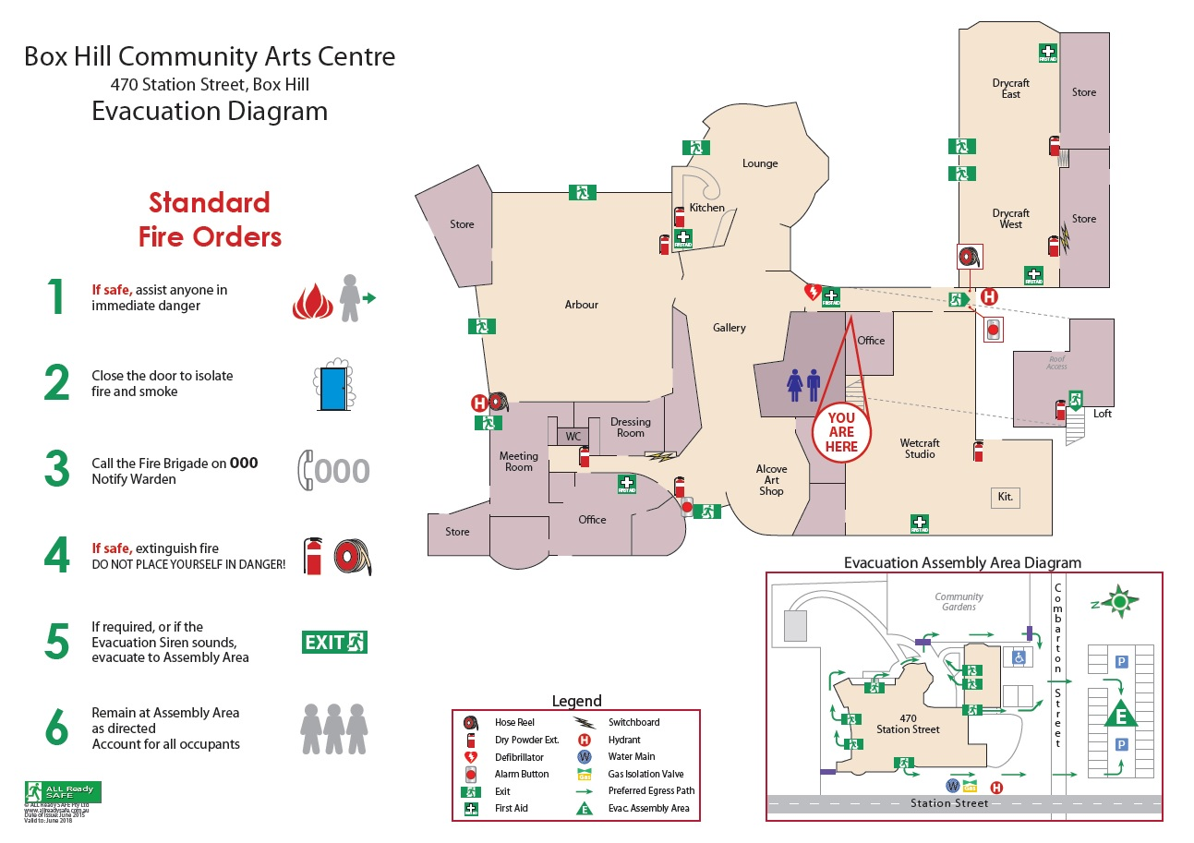
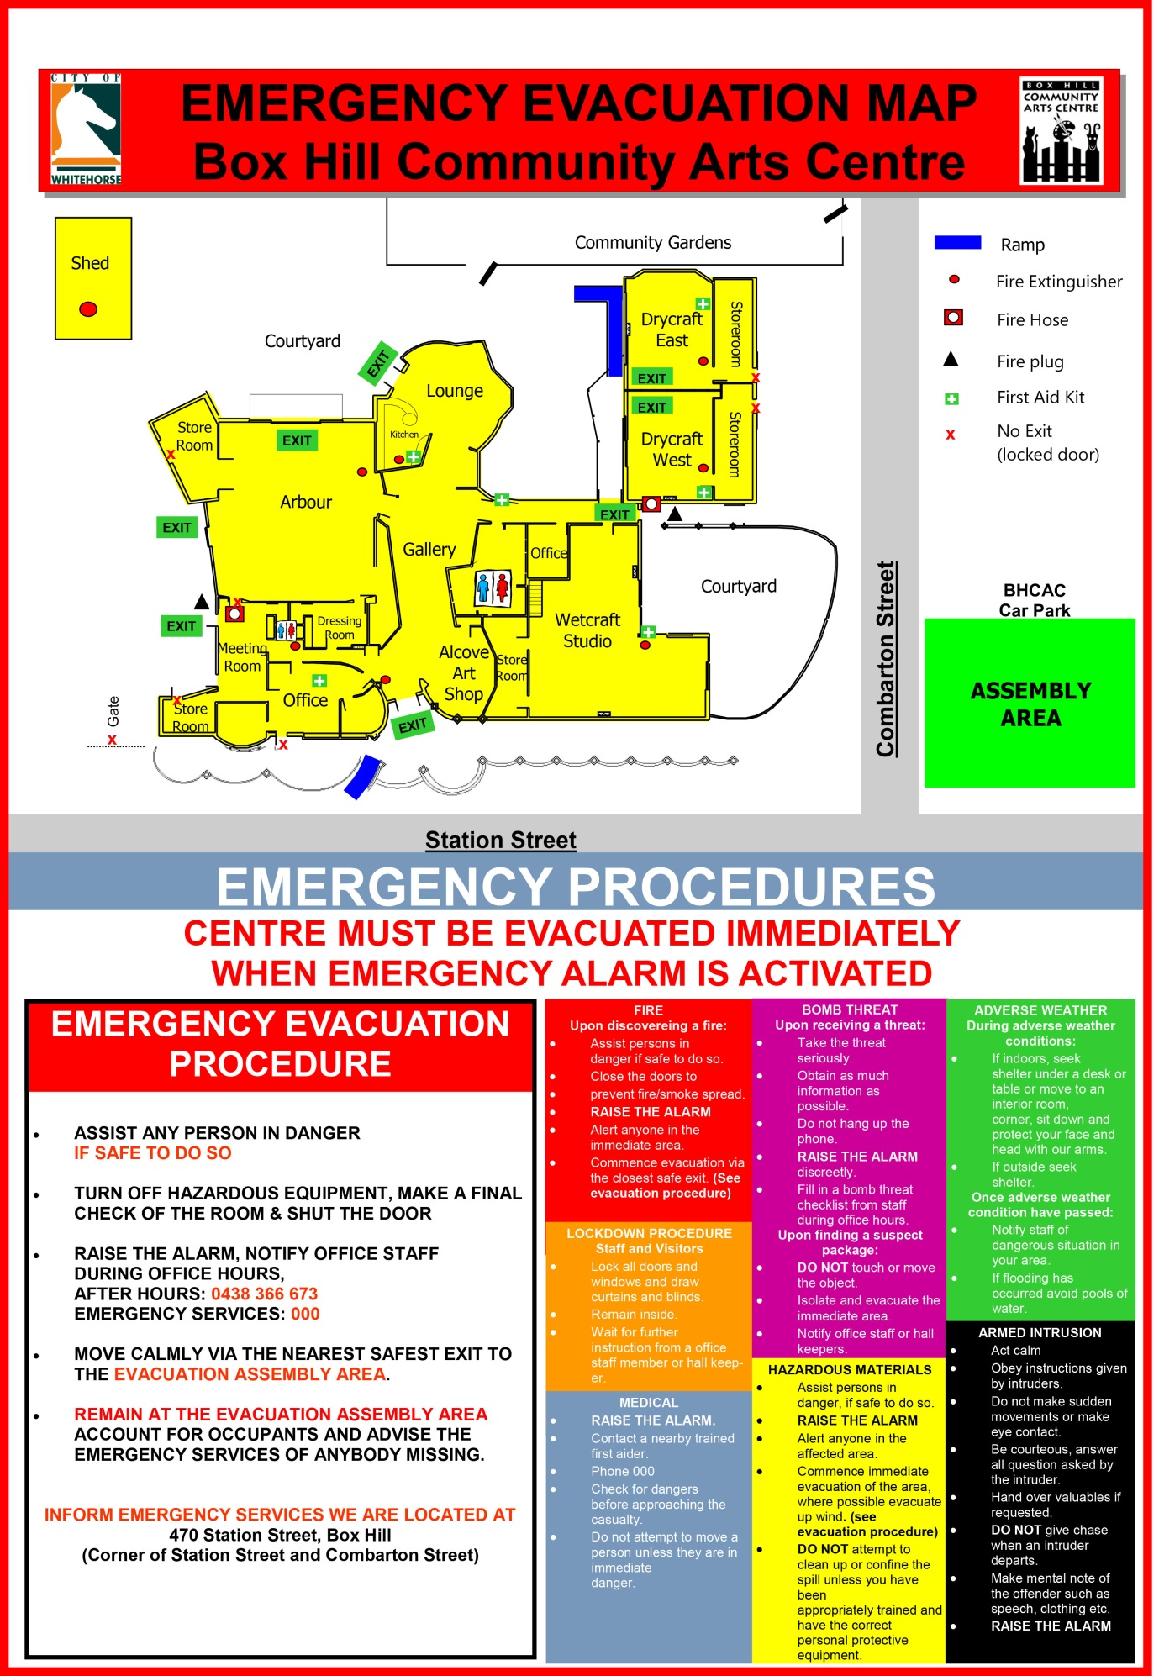

6. Venue Hire Rates and Application for Hire

6.1 Venue Hire Rates – Causal Hirer Rates

Centre Management reserves the right to review fees and charges, to have discretionary powers over access and to set any special conditions it deems appropriate provided they fit within the aims and objectives of the BHCAC.

Casual Hourly Rates – (Weekdays)

ROOM REQUIRED | Standard Rate Per hour (Incl. GST)
The Arbour (Multi-purpose Hall)  Seating for 120-175/Dimensions 11.5 x 12.5m  Casual Arts Performance/Workshop  Corporate/Casual Function | $77.70  $95.10
The Lounge/Kitchen  Seating for 40/Dimensions 7.5 x 8.5m | $74.45
Drycraft Studio (East or West)  Seating for 30/Dimensions 8 x 7m | $63.20
Drycraft Studio (East & West)  Seating for 50-60/Dimensions 16 x 7m | $90.40
Meeting Room  Seating for 20/Dimensions 7.5 x 4m | $38.85

Public Liability Insurance: If you/your group do not possess such insurance an extra charge of $15 per session will apply to be covered under Whitehorse City Council’s Hirers Policy.

A 50% surcharge may be required, in addition to normal payment, for bookings that begin before 9am and end after 10pm weekdays.

6.2 Venue Hire Rates – Function Rates & Equipment Hire Rates

Function Rates – (Friday Evenings, Sat & Sun)

ROOM REQUIRED | Standard Rate (including GST)
The Arbour (Multi-purpose Hall)  Seating for 120-175/Dimensions 11.5 x 12.5m | $625.00
The Lounge/Kitchen  In addition to arbour hire  Seating for 40/Dimensions 7.5 x 8.5m | $175.00
The Lounge / Kitchen  Seating for 40/Dimensions 7.5 x 8.5m | $430.00
Drycraft Studio (East or West)  Seating for 30/Dimensions 8 x 7m | $317.00
Drycraft Studio (East & West)  Seating for 50-60/Dimensions 16 x 7m | $511.25

These rates apply to functions between 5pm Fridays and 11.30pm Sundays.

Time booked in excess of 6 hours will attract the applicable hourly casual rate in addition to the function rate.

All bookings finishing after 7pm on weekends will incur a $60.00 surcharge.

As BHCAC is situated in a residential neighbourhood, all loud noise must cease at 10pm and bookings are required to end at 11.30pm.

Public Liability Insurance: If you/your group do not possess such insurance an extra charge of $15 per session will apply to be covered under the Whitehorse City Council Hirers Policy.
Equipment Hire Rates

EQUIPMENT ITEM | PRICE
Portable PA (includes microphone, CD player and auxiliary input) | $36.80
TV/DVD Player | $24.50
Data Projector/Laptop/Screen | $36.80
Portable Projector Screen | $16.40
Whiteboard | Free of charge
Barbeque | $36.80
Professional Audio/Lighting (Arbour Hall) | POA
Print Press (Requires Induction) | $70

6.3 Venue Hire Rates – Regular Hirer Rates

Regular Hourly Rates

ROOM REQUIRED | Standard Rate Per hour (Incl. GST)
The Arbour (Multi-purpose Hall)  Seating for 120-175/Dimensions  11.5 x 12.5m | $51.10
The Lounge/Kitchen  Seating for 40/Dimensions 7.5 x 8.5m | $42.50
Drycraft Studio (East or West)  Seating for 30/Dimensions 8 x 7m | $29.25
Drycraft Studio (East & West)  Seating for 50-60/Dimensions 16 x 7m | $58.50
Meeting Room  Seating for 20/Dimensions 7.5 x 4m | $30.70

A regular hirer is classified as such if they hire BHCAC more than six (6) times per year.

A 50% surcharge may be required, in addition to normal payment, for bookings that begin before 9am and end after 10pm weekdays.

All bookings finishing after 7pm on weekends will incur a $60.00 surcharge (not covered by City of Whitehorse Discount Support).

Advanced payment of the first four bookings is required for all NEW regular bookings.

All Regular Hirers must possess Public Liability Insurance (with a minimum of $20,000,000 coverage).

  - Application for Hire

OFFICE USE ONLY | No. |  | Date |  | Date
Booking ID |  | Invoiced / Paid |  | Discount Support Processed
Debtor Number |  | Public Liability Received |  | Booking Confirmation Signed
 |  |  |  | OHS Induction Completed

HIRER DETAILS
All sections of this form MUST be completed.
Name of Org/ Club/ Group/ Individual: ................................................................................................………………….…………………………………………..
Postal Address:........................................................................................................................................
Principal Contact: .....................................................................…............................................................ Position/Title:.............…………………………………………………………………………………………………………………….……
Telephone: B/H ..............................……... A/H .......….........................……Mobile …………..…………….………
Email Address.……………………………………………………………………..… Fax …..……………………………….………….….
Secondary Contact: ...................................................................................…............................................ Position/Title:.............…………………………………………………………………………………………………………………….……
Telephone: B/H ..............................……... A/H .......….........................……Mobile …………..…………….………
Email Address.……………………………………………………………………..… Fax …..…….…………………………….……….…
Invoicing Frequency (Regular Users only): Yearly (in advance) Quarterly Monthly
Invoicing Address (if different from principal contact): Name..............................................................................................................……………………………………….Postal………………….………………………………………………….Email……………….…..................................................
BOOKING DETAILS

Description of Activity:............................................................................................................................
Expected number of participants per session (MUST BE COMPLETED): ...............................................
Room(s)  Eg: Meeting Room | Day(s)  Eg: Monday | Time(s)  Eg: 9am – 1pm | Start Date  Eg: 1/2/2020 | Finish Date  Eg: 29/11/2020

Please turn over
Equipment Required:
Availability must be confirmed with Centre Management two weeks prior to bookings.
Equipment Item | Tick | Equipment Item | Tick
Portable PA |  | Whiteboard
TV/DVD Player |  | Barbeque
Data Projector/Laptop/Screen |  | Professional Audio/Lighting (Arbour Hall)
Portable Projector Screen |  | Print Press (Requires Induction)

Bookings required during school holiday periods (Regular Users only):
Yes No

Are you applying for City of Whitehorse Discount Support - Hall Hire?
Yes - Please attach signed application form / documentation
No

Do you have Public Liability Insurance with a minimum $20,000,000 Coverage?
Yes - Please provide a copy of your Certificate of Currency
No (Public Liability fee of $15 per booking will be charged)
The City of Whitehorse CANNOT provide Public Liability Insurance for Regular Hirers
Are there are any members of your group with mobility and other impairments which could affect their ability to be aware of or evacuate from the facility in the case of an emergency?
Yes (Please complete a Personal Emergency Evacuation Plan (PEEP) form)
No
HIRERS AGREEMENT
I/we have read and agree to comply to, in all respect, with the Conditions of Hire within the BHCAC Venue Hire Application Pack. I have read and understand the BHCAC Emergency Information and will convey this information to all members of the hiring group and visitors. Where the Hirer is a company or incorporated association, I am authorised to complete the application form on the Hirers behalf.

Name………………………………………………………………………………………………………………………………………………….
Group (if applicable)…………………………………………………………………………………………………………………………..
Emergency Procedures Nominated Member………………………………………….…………………………………………
Position Held in Group…………………………………………………………………………………………………………………………
Phone No:………………………………………………Mobile No:………………………………………………………………………….
Email Address:……………………………………………………………………………………………………………………………………..
Signed………………………………………………………………………………………Date………………………………………………….

Privacy Notification
Personal information requested such as name and address, is collected for the purpose of registering and administering applications for hiring council facilities. The personal information collected will not be used for any other purpose or disclosed except as may be required by law. If you do not provide the information then your application may not be processed. You may access the information collected about you by contacting the BHCAC Centre Coordinator on 9895 8888.

